**Practical No 02**

**1.Simple Queries with MongoDB.**

**A]Insertion:**

**For insert one:** db.student.insertOne({ name: "Anita", age: 19, course: "BCom", marks: 78 })

**Output:**

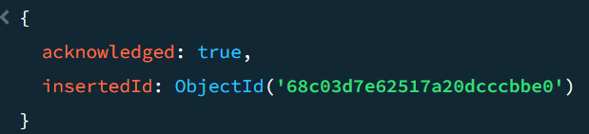

**For insert many:** db.student.insertMany([{ name: "Rohit", age: 21, course: "BSc", marks: 85 },

{ name: "Sneha", age: 20, course: "BCA", marks: 90 },

{ name: "Vikas", age: 22, course: "MBA", marks: 72 },

{ name: "Meena", age: 23, course: "BSc", marks: 88 }

])

**Output:**

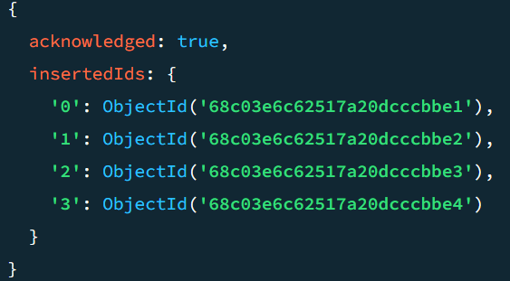

**B]Show data:** db.student.find()

**Output:**

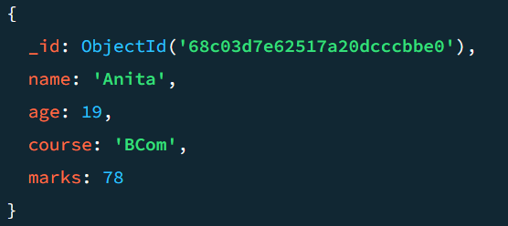

**C]Condition query:** db.student.find({ age: { $gt: 21 } })

**Output:**

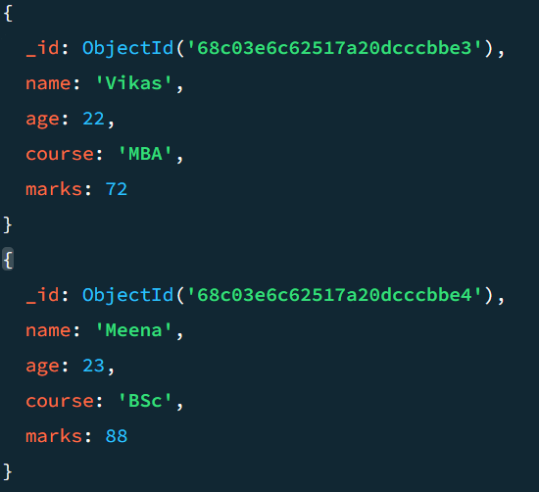

**D]Update:** db.student.updateOne({ name: "Anita" },{ $set: { age: 18 } })

**Output:**

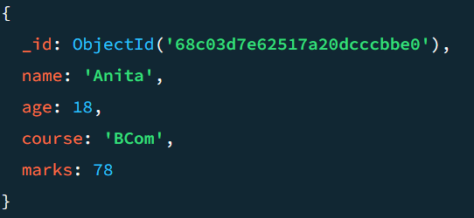

**E]Delete one record:** db.student.deleteOne({ name: "Rahul" })

**Output:**

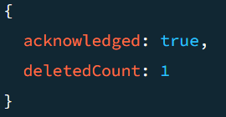

**F]Limit:** db.student.find().limit(2)

**Output:**

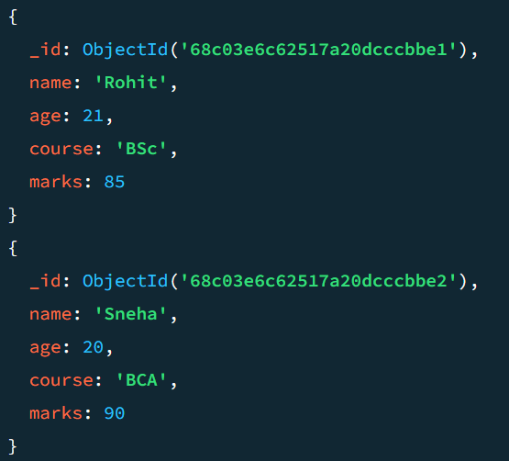

**G]Projection:** db.student.find({}, { name: 1, course: 1 })

**Output:**

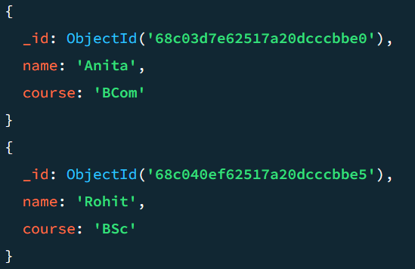

**H]Drop database:** db.students.drop()

**Output:**

